Project Report On AI-Based Personal Tutor Webapp
Submitted in the partial fulfilment of the requirement for the award of degree of

Bachelor of Technology
In
Computer Science and Engineering
Batch

(2022 - 2026)



Submitted to: Submitted by:
Mrs. Ridhi Kapoor Aastha
Assistant Prof. (CSE) 12200818

DEPARTMENT OF COMPUTER SCIENCE AND ENGINEERING
DAV UNIVERSITY
JALANDHAR-PATHANKOT NATIONAL HIGHWAY, NH 44,
SARMASTPUR, PUNJAB
144012

ACKNOWLEDGEMENT
I would like to express my sincere gratitude to my project guide, Ridhi Kapoor, for their valuable guidance, constructive feedback, and continuous support throughout the duration of this project. I am also thankful to Dr. Rahul Hans and the Department of B.Tech Cs & Ai for providing the necessary resources and an encouraging academic environment.

My appreciation extends to all faculty members and classmates whose suggestions and cooperation helped strengthen the quality of this work. Lastly, I am deeply grateful to my family for their constant encouragement and support, which motivated me to complete this project successfully
DECLARATION
I, Aastha Sharma, hereby declare that the work which is being presented in this project/training titled “AI-Based Personal Tutor Webapp” by me, in partial fulfilment of the requirements for the award of Bachelor of Technology (B.Tech) Degree in “Computer Science and Engineering with Artificial Intelligence” is an authentic record of my own work carried out under the guidance of “Ridhi Kapoor”.
To the best of my knowledge, the matter embodied in this report has not been submitted to any other University/ Institute for the award of any degree or diploma.
Aastha
12200818
Dr. Rahul Hans
(Coordinator of Department, CSE)

ABSTRACT
The BioUniverse Encyclopedia is a captivating and comprehensive reference work that unveils the remarkable tapestry of life on Earth. From microorganisms to magnificent creatures, this encyclopedia offers a captivating exploration of the diverse array of living organisms. Through engaging narratives, vivid illustrations, and informative descriptions, readers will embark on a journey that unveils the intricacies and wonders of the natural world. Organized into thematic chapters, each section delves into specific branches of life, shedding light on the unique characteristics, habitats, and evolutionary adaptations of the featured organisms. This encyclopedia serves as an enlightening gateway to the astonishing realm of living organisms, fostering a deeper understanding and appreciation for the biodiversity that sustains our planet.

TABLE OF CONTENTS
Chapter |  |  | Table Of Contents | Page No.
1 |  |  | Introduction
 | 1.1 |  | Introduction to Front End development
 | 1.2 |  | Technologies
 | 1.3 |  | ReactJS
 | 1.4 |  | Supabase
 | 1.5 |  | Advantages of ReactJS
 | 1.6 |  | Application of ReactJS
2 |  |  | Project Title and Overview
 | 2.1 |  | Project Title
 | 2.2 |  | Project Overview
 |  | 2.2.1 | Existing System
 |  | 2.2.2 | Proposed System
 |  | 2.2.3 | Features
 |  | 2.2.4 | System Requirement Specifications
 |  | 2.2.5 | Software Tool Theoretical Background
3 |  |  | Objective
 | 3.1 |  | Objective
4 |  |  | Project Design
 | 4.1 |  | Modules of Project
 | 4.2 |  | Data Flow Diagram
5 |  |  | Coding & Implementation
6 |  |  | Conclusion
 | 6.1 |  | Conclusion
 | 6.2 |  | Maintenance
 | 6.3 |  | Future Scope
7 |  |  | References

CHAPTER 1
INTRODUCTION

  - INTRODUCTION TO FRONT END DEVELOPMENT

Front-end development using React involves leveraging the React library to build user interfaces for web applications. React is a JavaScript library developed by Facebook that provides a component-based approach to front-end development, allowing developers to create reusable UI components and efficiently manage the application's state.
At the core of React is the concept of components. A component is a self-contained, reusable piece of code that represents a part of the user interface. Each component can have its own state and properties (props), which determine its behavior and appearance. React components are built using JSX (JavaScript XML), a syntax extension that allows HTML-like code within JavaScript, making it easier to describe the structure and appearance of components.
React's virtual DOM (Document Object Model) implementation is one of its key features. The virtual DOM is a lightweight representation of the actual DOM, which is the browser's internal data structure representing the web page. When a component's state or props change, React efficiently calculates the difference between the current and new virtual DOM and updates only the necessary parts of the actual DOM. This approach minimizes unnecessary re-rendering and improves performance.
To get started with React development, you need to set up a development environment. This typically involves installing Node.js and npm (Node Package Manager) to manage dependencies. React applications are created using the Create React App tool, which sets up a project structure and provides a development server.
React components can be functional or class-based. Functional components are simpler and rely on JavaScript functions, while class-based components are more powerful and offer additional features. Functional components are recommended for most use cases unless you specifically require the features provided by class-based components, such as state management or lifecycle methods.
To create a React component, you define a function or class that returns JSX. JSX combines HTML-like syntax with JavaScript to describe the structure and appearance of the component. You can use HTML tags, custom components, and JavaScript expressions within JSX. React components can also have properties (props) that are passed from parent components and can be used to configure the behavior or appearance of the component.
In conclusion, front-end development using React involves building user interfaces for web applications using the React library. React's component-based architecture, virtual DOM, and unidirectional data flow pattern provide an efficient and scalable approach to front-end development. By creating reusable components, managing state, and leveraging the React ecosystem, developers can build interactive and responsive user interfaces with ease.

  - Technologies

- HTML:
HTML, which stands for Hypertext Markup Language, is the standard markup language used for creating web pages and applications. It provides the structure and content of a web page, defining the elements and their arrangement. HTML uses tags to markup elements and specify their meaning or purpose within the document.

Here are some key points about HTML:

- Structure: HTML defines the basic structure of a web page, consisting of elements such as headings, paragraphs, lists, links, images, and more. These elements are enclosed in opening and closing tags that surround the content.
- Tags: HTML tags are keywords surrounded by angle brackets ("<" and ">") that define the elements on a web page. Tags are typically used in pairs, with an opening tag ("<tag>") and a closing tag ("</tag>"), wrapping the content that they affect.

- Nesting: HTML elements can be nested inside one another to create hierarchies and define relationships between elements. However, it's important to ensure proper nesting and matching of opening and closing tags.

HTML serves as the foundation for web development, providing the structure and content of web pages. It works in conjunction with other technologies like CSS (Cascading Style Sheets) for styling and JavaScript for interactivity, creating rich and dynamic web experiences. HTML is supported by all web browsers and is a fundamental skill for anyone involved in web development.

- CSS:

CSS, which stands for Cascading Style Sheets, is a style sheet language used for describing the presentation and visual layout of web pages. It works alongside HTML to define how elements are styled and displayed on a web page.
Here are some key points about CSS:

- Styling Elements: CSS allows you to apply styles to HTML elements, such as setting colors, fonts, margins, padding, borders, and more. With CSS, you can control the visual appearance and layout of individual elements or groups of elements.

- Selectors: CSS uses selectors to target specific HTML elements for styling. Selectors can be based on element names, classes, IDs, attributes, or their hierarchical relationship within the HTML structure. Selectors determine which elements the styles will be applied to.

- Cascading Nature: CSS follows a cascading nature, meaning that multiple styles can be applied to the same element, and the styles are applied based on a specific order of precedence. This allows you to define styles at different levels, such as inline styles, internal stylesheets, or external stylesheets, and the styles will be applied in a cascading manner.

CSS plays a crucial role in web development, allowing you to transform HTML documents into visually appealing and well-structured web pages. It provides extensive control over the presentation of elements, enabling consistent styling, layout, and responsiveness across various devices and screen sizes. CSS is supported by all modern web browsers and is an essential skill for front-end web developers.

- JavaScript:

JavaScript is a versatile and popular programming language primarily used for adding interactivity and dynamic functionality to web pages. It is a client-side scripting language, meaning it runs directly within web browsers and can be used to manipulate and interact with HTML elements, handle user events, and communicate with servers.

Here are some key points about JavaScript:

- Client-Side Scripting: JavaScript runs in the browser and allows developers to create interactive and dynamic web pages. It enables actions such as form validation, DOM manipulation, event handling, and animations, enhancing the user experience.

- Versatility: JavaScript is a multi-paradigm language, supporting both object-oriented and functional programming styles. It offers a wide range of features and capabilities, making it suitable for various applications, including web development, server-side scripting, mobile app development, and more.

- Server-Side Development: With the advent of Node.js, JavaScript can now be used for server-side development as well. It allows developers to build scalable and efficient web servers, handle server-side logic, interact with databases, and create full-stack applications using a unified language.

JavaScript is supported by all major web browsers and has become an integral part of modern web development. It empowers developers to create interactive and engaging web experiences, enabling dynamic content updates, real-time communication, and seamless user interactions. Learning JavaScript opens up a wide range of opportunities for front-end and full-stack web development.

  - ReactJS

React.js, also known as React, is an open-source JavaScript library developed by Facebook. It has gained immense popularity among developers for building user interfaces in web applications. React follows a declarative and component-based approach, allowing developers to create interactive, reusable, and scalable UI components.

At the core of React's philosophy is the concept of components. A component is a self-contained, reusable piece of code that represents a part of the user interface. It encapsulates the logic and presentation of that particular part, making it easy to reuse, test, and maintain. Components can be composed together to form complex UI structures.

One of the key advantages of React is its virtual DOM (Document Object Model) implementation. The DOM is a programming interface for web documents, representing the structure of HTML or XML elements. Manipulating the DOM directly can be slow and inefficient, especially when dealing with complex UI updates.

In conclusion, React.js is a powerful JavaScript library that simplifies the creation of interactive and reusable user interfaces. Its component-based architecture, virtual DOM, and unidirectional data flow enable efficient and scalable development. React's emphasis on reusability, along with its vibrant community and extensive ecosystem, has made it one of the most popular choices for building modern web applications. Whether you are a beginner or an experienced developer, React provides the tools and resources necessary to create dynamic and engaging user interfaces.

  - Supabase

Supabase is an open-source backend platform that helps developers build web and mobile apps faster. It provides ready-made tools like authentication, database, storage, and APIs, so developers don’t need to create everything from scratch. Supabase is built on top of PostgreSQL, which is a powerful and reliable database used in many modern applications.
With Supabase, developers get features such as user sign-up/sign-in, real-time data updates, secure data handling, and built-in admin dashboards. It works as a complete backend solution where all data can be stored, managed, and accessed easily. Because it is simple to use and gives instant APIs for your database tables, Supabase is very useful for small projects, startups, and even large scalable apps.
In this project, Supabase is used for authentication, storing generated courses, managing users, and handling the admin dashboard. This makes the whole system faster to build and easier to maintain.

  - Advantages of React

React is a widely adopted JavaScript library that offers several advantages for web development. Here are the key advantages of using React:

- Component-Based Architecture: React follows a component-based architecture, allowing developers to break down the user interface (UI) into self-contained, reusable components. Components encapsulate their own logic, styling, and state, making them easier to understand, test, and maintain. This modular approach promotes code reusability, reduces redundancy, and improves overall development efficiency.

- Virtual DOM and Efficient Rendering: React utilizes a virtual representation of the Document Object Model (DOM) called the Virtual DOM. The Virtual DOM is a lightweight copy of the actual DOM that React keeps in memory. When changes occur in the application's state, React efficiently updates the Virtual DOM and performs a diffing algorithm to identify the minimal set of changes required to update the actual DOM. By minimizing direct manipulation of the DOM, React significantly improves rendering performance, resulting in a smoother and more responsive user interface.

- Reusable Components and Code Modularity: React's component-based architecture allows developers to create reusable UI components. These components can be used across different parts of the application or shared between projects. Reusability reduces code duplication, improves maintainability, and speeds up development by promoting the use of pre-built components.

- Declarative Syntax: React uses a declarative syntax, allowing developers to describe the desired UI state and React takes care of updating the UI to reflect that state. This makes the code more readable, easier to reason about, and less prone to bugs. Developers can focus on describing what the UI should look like rather than worrying about the imperative details of how to update it.

- Large and Active Community: React has a large and active community of developers, which means there are abundant resources, tutorials, and community-driven projects available. The community provides continuous support, releases updates, and shares best practices. This ecosystem makes it easier to learn React, find solutions to problems, and stay up to date with the latest trends and developments.

In summary, React's component-based architecture, efficient rendering, code reusability, declarative syntax, vibrant community, extensive ecosystem, and support for server-side rendering and mobile development make it a powerful and popular choice for web development. React empowers developers to build scalable, maintainable, and high-performance applications with a superior user experience.

  - Applications of React

React is a versatile library that finds application in various types of web development projects. Here are some common applications of React:

- Single-Page Applications (SPAs): React is widely used for building single-page applications where all content and functionality are presented within a single web page. React's component-based architecture enables developers to create reusable UI components, which can be easily composed and updated as the application state changes. The efficient rendering of React's Virtual DOM ensures fast and responsive user interfaces, making it a popular choice for SPAs.

- User Interfaces (UIs): React excels at building interactive and dynamic user interfaces for web applications. Its component-based approach allows developers to break down complex UIs into manageable and reusable parts. React components encapsulate their logic and styling, making it easier to maintain and update UI elements. With React's declarative syntax, developers can express the desired UI state, and React takes care of updating the UI efficiently.

- Prototyping and Rapid Development: React's simplicity and reusability make it a popular choice for prototyping and rapid development. Developers can quickly create UI components using React, allowing for fast iteration and testing of design ideas. React's modular architecture promotes code reuse and simplifies maintenance, making it ideal for projects that require frequent changes and updates.

- Data Visualization: React can be combined with data visualization libraries, such as D3.js or Chart.js, to create interactive and visually appealing data visualizations. React's ability to efficiently update components based on changing data makes it well-suited for building dynamic and responsive visualizations. By combining React's component-based approach with powerful data visualization libraries, developers can create engaging and interactive charts, graphs, and other visual representations of data.

In conclusion, React has found applications in a wide range of web development scenarios. Its component-based architecture, efficient rendering, and ecosystem of tools and libraries make it a powerful choice for building interactive user interfaces, single-page applications, mobile applications, and much more. With its versatility and extensive community support, React continues to be a popular and influential technology in the web development landscape.
CHAPTER 2
PROJECT TITLE AND OVERVIEW

2.1 Project Title – AI-Based Personal Tutor Webapp
2.2 Project Overview
This project is an AI-based tutor web app. The user tells the app what they want to learn, and the system creates a full course for them. It makes chapters, tasks, and guides the user step-by-step. If the user gets stuck, the AI helps them understand the topic in an easy way. The goal is to give a personal learning experience to every user.

2.2.1 Existing System
The current learning systems mostly work like fixed online courses or static educational websites. They provide lessons, videos, and quizzes, but the content is the same for every learner. These systems depend on pre-written materials stored in a database. Users can only choose from the available courses and cannot customize their learning path.
However, these systems have many limitations:
- Fixed Content: The content is not adjustable. Users cannot learn exactly what they want. They must follow the same chapters as everyone else.
- No Personal Guidance: If the learner gets stuck, there is no instant help. They must search manually or watch long videos to understand the topic.
- Limited Interaction: Most platforms only offer videos and text. They do not provide tasks or exercises based on the user’s level.
- Slow Adaptation: Traditional systems do not change the course difficulty or pace based on the user’s performance.
- Time-Consuming Learning: Users spend more time searching for explanations instead of learning smoothly inside one platform.
- No Real-Time Support: There is no system that answers user questions in real time within the course.
- Lack of Customization: Users cannot create their own course outline or choose chapters specific to their learning goals.
Understanding these problems shows why a more advanced, AI-based system is needed for modern learners.

2.2.2 Proposed System
The proposed system is an AI-based tutor web app that creates fully dynamic learning paths for every user. Instead of giving fixed content, the system generates custom courses based on what the user wants to learn. The app also provides real-time assistance whenever the user asks for help.
Here are the main components of the proposed system:
- AI-Generated Courses
  - Users enter any topic they want to learn.
  - The AI creates a complete course with chapters, examples, and tasks.
  - The course structure is unique for every user.
- Real-Time Learning Support
  - If the user is stuck, they can chat with the AI.
  - The AI explains the concept, provides hints, or solves small examples.
  - This feels like having a personal tutor available 24/7.
- Adaptive Learning Flow
  - The system adjusts difficulty based on the user’s progress.
  - It gives easier explanations to beginners and deeper explanations to advanced users.
- Interactive Tasks and Practice
  - The AI generates practice problems for each chapter.
  - Tasks can also be customized based on user input.
  - The AI checks the user’s answers and explains mistakes.
- User-Friendly Interface
  - Simple, clean, and responsive UI.
  - Users can easily move through chapters, tasks, and help sections.
- Search and Quick Access
  - Users can search for any topic inside the app.
  - The AI gives short answers, examples, or direct chapter links.
- Personalized Learning History
  - The system remembers what the user has learned.
  - It recommends related topics or next steps.
- Scalable Architecture
  - The system supports many users at once.
  - It can handle large amounts of AI-generated data.
  - Designed to grow without performance issues.
- Secure User Authentication
  - Users can register and log in.
  - Personal progress and learning history are protected.
  - Secure communication ensures user data safety.
The proposed AI tutor system aims to make learning more personal, fast, and interactive. It removes the limitations of traditional platforms and gives each user a unique and smooth learning journey.

2.2.3 Features
- AI-generated custom courses: The system creates a fully personalized course based on the topic the user enters. This helps every learner get content that fits their exact needs.
- Auto-created chapters and tasks: The AI breaks the topic into clear chapters and makes related tasks automatically. This helps the user learn step by step.
- Real-time help when the user is stuck: Users can ask questions any time, and the AI gives instant explanations or hints. It works like a personal tutor always available.
- Simple and clean web interface: The interface is clean, modern, and easy to navigate. This makes learning smooth and free from distractions.
- User-friendly learning flow: The app guides the user through chapters in a natural order. It makes learning comfortable even for beginners.
- Support for any topic the user enters: The system can generate content for any subject typed by the user. This gives complete freedom to learn anything.

    - System Requirement Specifications

- Software Requirements:
- Operating System: Compatible with major operating systems such as Windows, macOS, or Linux.

- Node.js: Latest stable version of Node.js runtime environment installed.

- Code Editor: A preferred code editor such as Visual Studio Code, Atom, or Sublime Text for development.

- Package Manager: Node Package Manager (NPM) or Yarn for managing dependencies and building the project.

- Front End: HTML, CSS, Bootstrap, JavaScript, ECMA Script, React JS

- Hardware Requirements:
- Processor: A modern multi-core processor, such as Intel Core i3 or AMD Ryzen 3, or higher for efficient development.

- Memory (RAM): At least 8GB of RAM, although higher amounts are recommended for smoother development experience.

- Storage: Adequate disk space to store the project files and dependencies .

- Display: A monitor with a resolution of 1280x800 pixels or higher for comfortable development.

These are the minimum software and hardware requirements for a React website development environment. However, It's always recommended to refer to the official documentation and guidelines of React, the specific libraries, and the tools you intend to use for project. This will ensure optimal performance and compatibility, as the requirements can vary based on the specific dependencies and configurations of project.

    - Software Tool Theoretical Background

- Introduction to VS Code: Visual Studio Code (VS Code) is a popular source code editor developed by Microsoft. It is widely used by developers for various programming languages and platforms. Here's a brief overview of VS Code:

- Lightweight and Versatile: VS Code is designed to be lightweight and fast, making it suitable for various development tasks. It supports a wide range of programming languages and provides a versatile environment for coding, debugging, and testing.

- Cross-Platform Compatibility: VS Code is available for Windows, macOS, and Linux operating systems, ensuring compatibility across different platforms. This allows developers to work seamlessly on their preferred operating systems.

- Feature-Rich Editing: VS Code offers a rich set of editing features to enhance productivity. It includes syntax highlighting, code completion, linting, formatting, and intelligent code suggestions. These features help developers write clean and error-free code efficiently.

Overall, Visual Studio Code is a highly versatile and feature-rich code editor that provides a productive environment for developers across different platforms. Its lightweight nature, extensive customization options, and strong ecosystem of extensions make it a popular choice among developers worldwide.

CHAPTER 3
OBJECTIVE

3.1 Objective
The main objective of the AI Tutor Web App is to provide users with a smart, personalized, and interactive learning platform where they can learn any topic they want in a simple and guided way. The system aims to make learning easier, faster, and more engaging by using AI to create custom courses, chapters, and tasks based on user needs. The key objectives of the AI Tutor Web App are:

1. Personalized Learning: To offer fully customized courses based on the user’s chosen topic. The app aims to give every learner content that matches their level, pace, and learning goals.
2. Easy-to-Use Interface: To provide a simple, clean, and user-friendly interface so users can move through chapters, tasks, and help options without confusion. The goal is to keep the learning experience smooth and stress-free.
3. Intelligent Support System: To help users instantly whenever they are stuck. The AI acts like a personal tutor, giving explanations, hints, and examples in real time, improving understanding and confidence.
4. Automated Course Structure: To break complex topics into small, clear chapters and related tasks. The objective is to make learning step-by-step, clear, and enjoyable.
5. Unlimited Topic Coverage: To support learning for any topic the user enters. This gives users complete freedom to explore anything—from programming to finance to general knowledge—without restrictions.
6. Engaging and Interactive Learning: To make learning more engaging by offering explanations, examples, and practice tasks created automatically by AI. This keeps the user active instead of passively reading.
7. Accurate and Reliable Content: To provide correct, updated, and high-quality explanations generated using advanced AI models. The goal is to ensure the user always receives trustworthy and useful information.
8. Accessibility and Device Compatibility: To make the app easy to use on desktops, tablets, and mobile devices. The system aims to give a seamless learning experience on any screen size, making learning possible anytime and anywhere.

In summary, the objective of the AI Tutor Web App is to create a modern, intelligent, and personalised learning environment that helps users learn anything with ease. By offering AI-generated courses, real-time support, simple design, and unlimited topic flexibility, the system aims to make learning more effective, enjoyable, and accessible for everyone.

CHAPTER 4
PROJECT DESIGN

4.1 Modules of Project

ADMIN
USER

- User Modules (Normal User):
  - Sign Up / Sign In - The User creates an account or logs into an existing account using Supabase Auth.

  - Create Course - The User enters a topic or a learning goal in the textbox. This input is used to generate a new course.

  - Generate Course with Gemini API - When the User submits the topic, the system sends the request to the Gemini API. The API generates chapters, lessons, and tasks.

  - Fetch YouTube Videos for Each Task - For every generated task, the system automatically fetches three YouTube videos using the YouTube API. These videos are attached to the task to help the user learn better.

  - View Courses - The User can see all the courses they have created.

  - Delete Course - The User can delete any course they created. The system updates the database accordingly.

  - Use Chatbot for Help - The User can chat with the built-in AI chatbot.
The chatbot uses the context of the user’s course and the user’s data this allows the chatbot to give personalised help.

- Admin Modules:
The Admin manages the entire system using the Supabase Dashboard.
• Manage Users - The Admin can view and manage all users in the system.
• View All Courses - The Admin can view every course created by any user.
• Manage Data in Supabase - The Admin controls the database, including user data, course data, and logs.

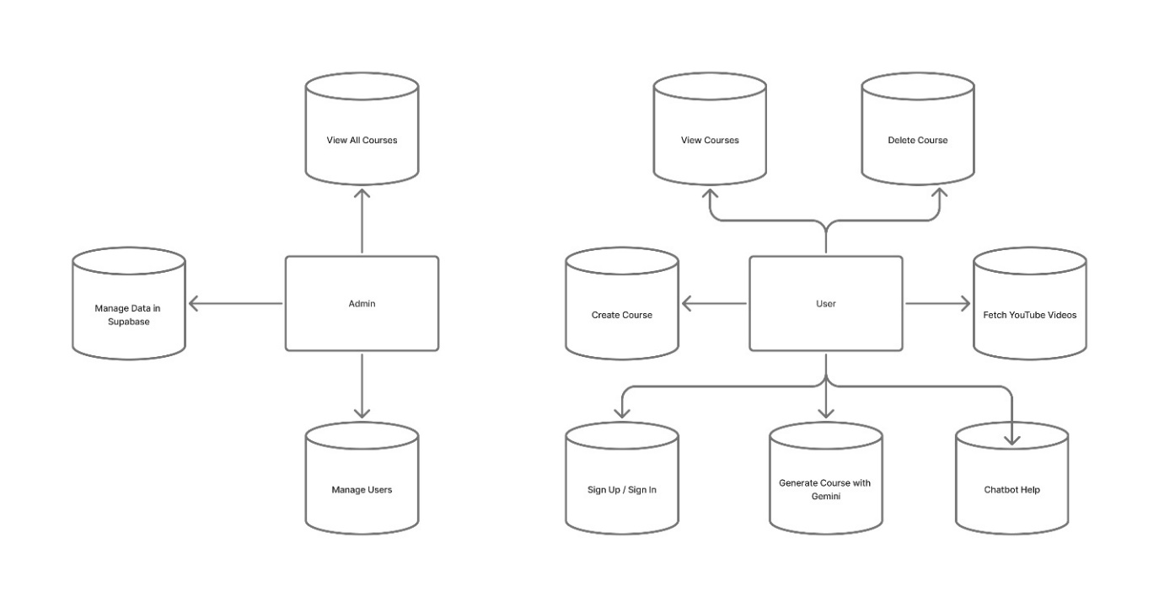
Technology Stack:
The AI-Based Personal Tutor Webapp is built using the following technologies:
- React: The core JavaScript library for building user interfaces.
- JSX: The syntax extension for JavaScript that allows the use of HTML-like syntax within React components.
- React Router: A routing library for handling navigation within the app.
- API Integration: The app integrates with external APIs to retrieve and display relevant information, images, and multimedia content.
- Supabase: It is an open-source backend platform that provides easy tools for authentication, databases, and APIs to help build apps faster.

Conclusion:
The AI Tutor Web App provides a modern and intelligent way of learning by creating personalised courses, clear chapters, and helpful tasks for any topic the user chooses. With real-time support, a simple interface, and flexible learning options, the system makes learning easier and more interactive. Overall, the project shows how AI can improve education by giving every user a custom and comfortable learning experience.

4.2 Data Flow Diagram

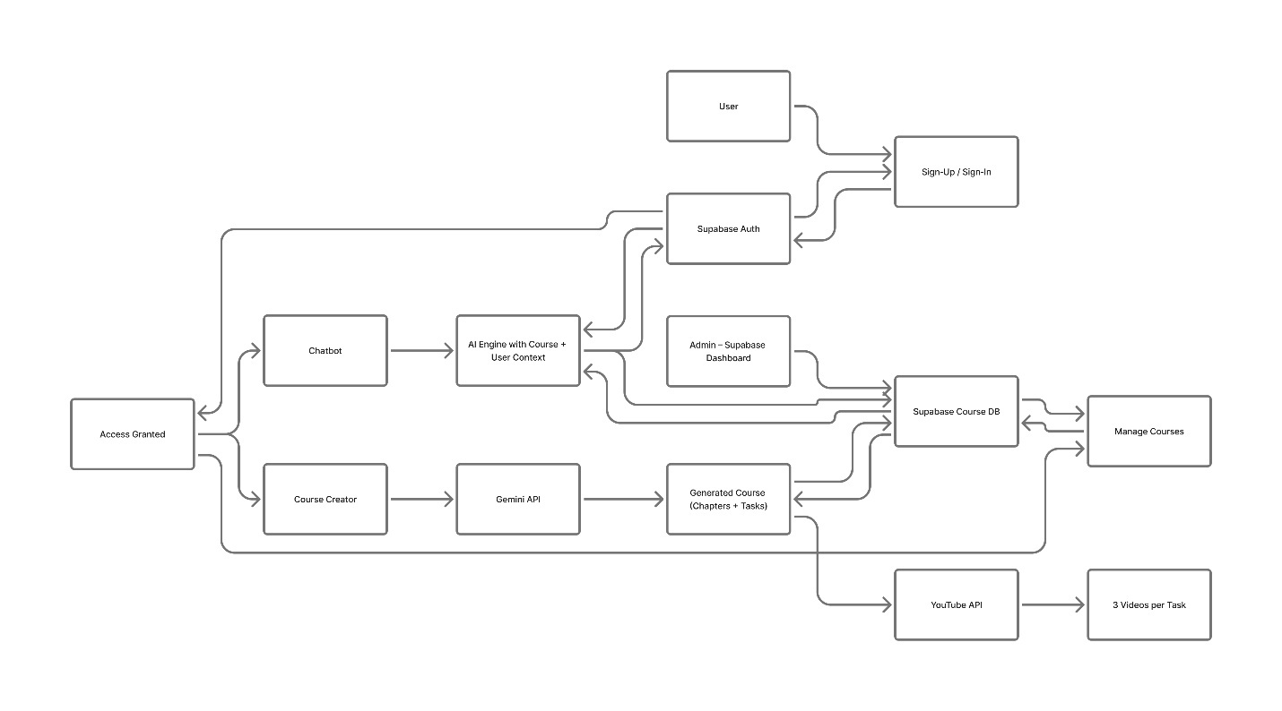

1. User → Sign Up / Sign In
The user must login first.
2. Sign In → Supabase Auth
When the user signs in:
- Supabase checks if the user exists
- If yes → access is given
- If no → user must sign up

3. Access Granted → Course Creator
User writes what they want to learn.
4. Course Creator → Gemini API
The text goes to Gemini API, which:
- Reads the user prompt
- Creates chapters
- Creates tasks inside each chapter

5. Gemini API → Course DB (Supabase)
The generated course is stored in your database.
Chapters + tasks are saved.

6. Course Generator → YouTube API
For each task:
- Your YouTube API call fetches 3 videos
- The videos are attached to the task

7. Access → Chatbot
Chatbot uses:
- Course data
- User data
- Context of what the user wants to learn

8. Manage Courses
User can:
- Create courses
- Delete courses
- View their courses

9. Admin → Supabase Dashboard
Admin controls everything using Supabase dashboard:
- Users
- Courses
- Data
- Logs

CHAPTER 5
CODING & IMPLEMENTATION
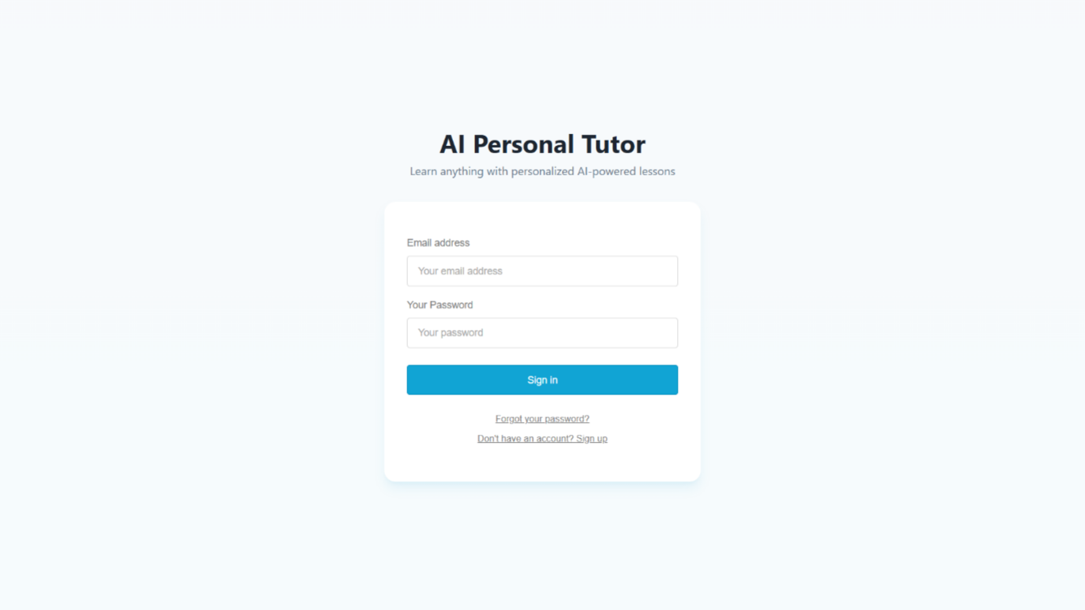

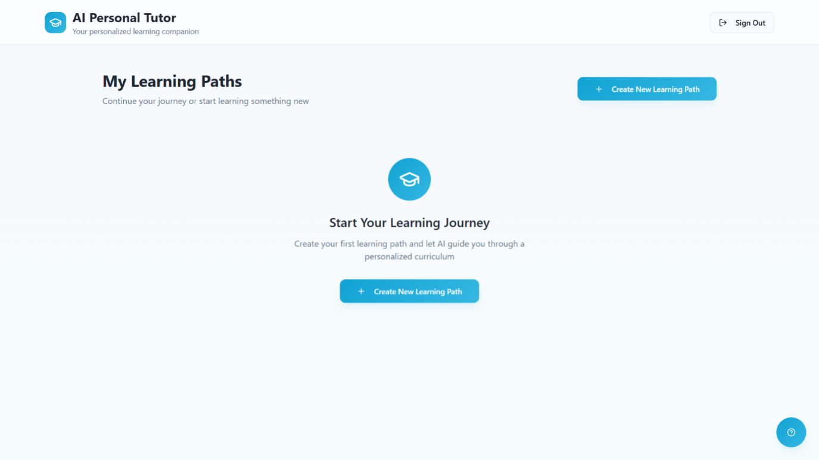

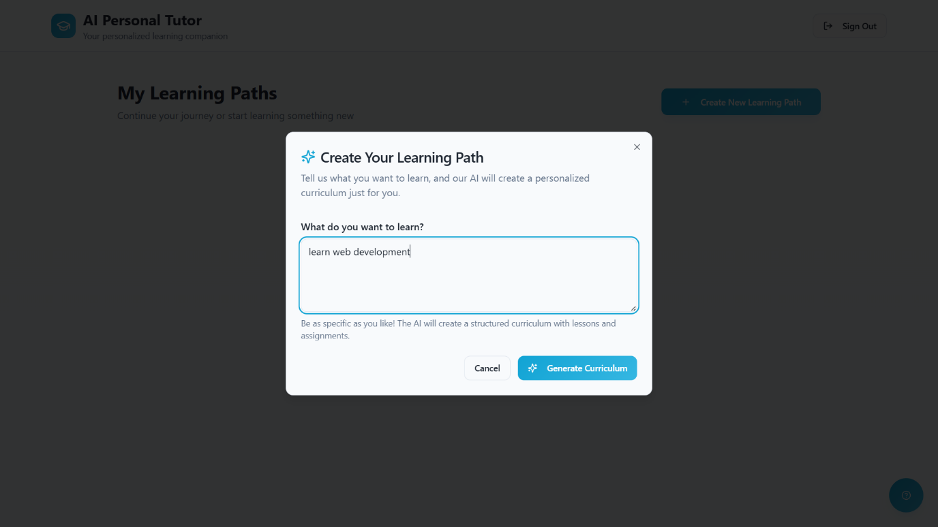

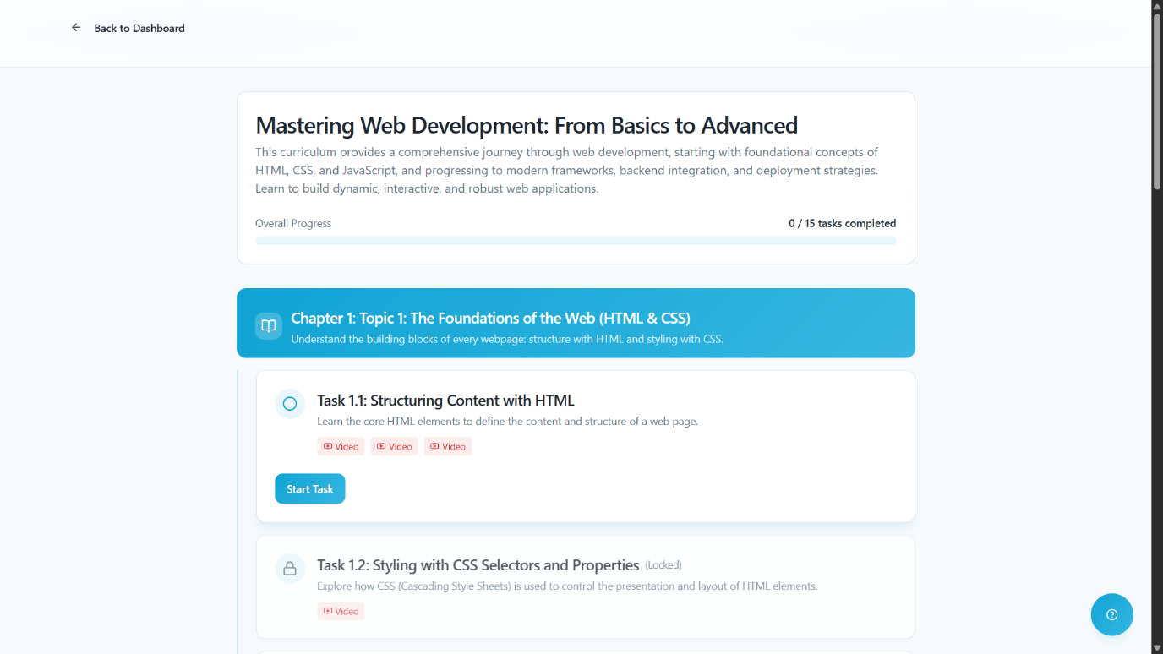
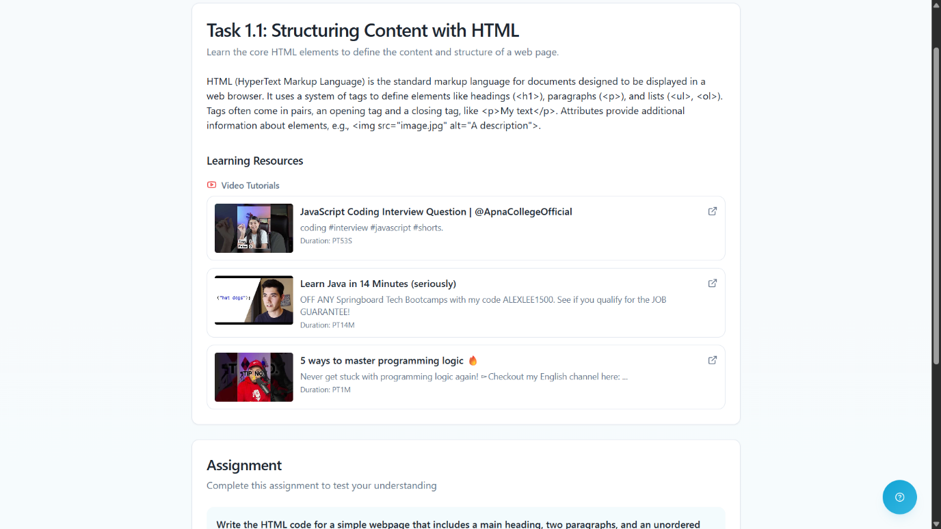

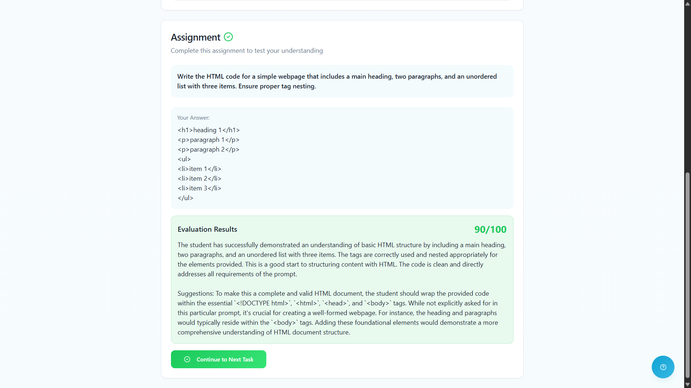
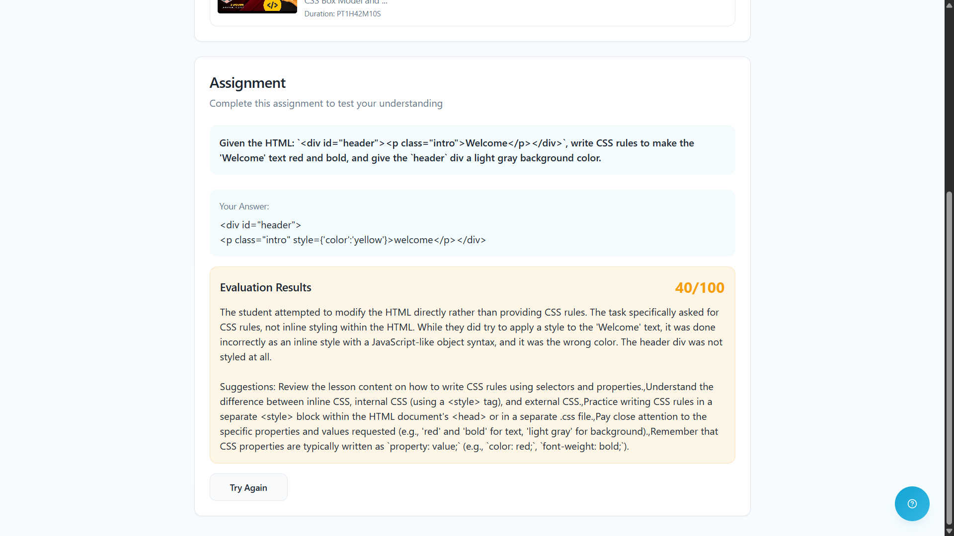

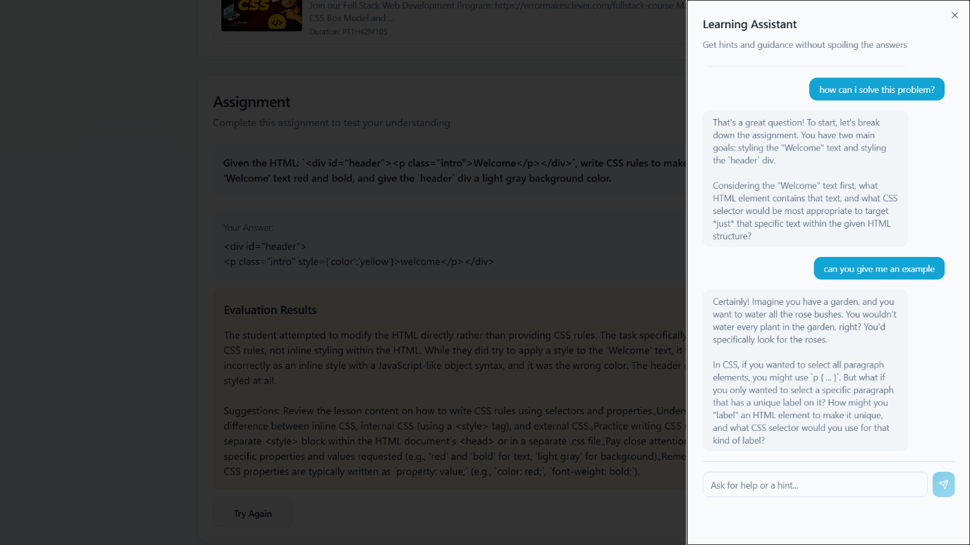

CHAPTER 6
CONCLUSION

  - Conclusion

This project report has outlined the complete plan for an "AI-Based Personal Tutor Webapp." The system is designed to provide a personalized and intelligent solution to the problem of educational resource discovery. By leveraging machine learning, specifically knowledge tracing and content filtering, the application will move beyond simple "keyword search" and provide suggestions tailored to each student's unique learning pace.

The development of this project will demonstrate a practical application of AI in educational technology, covering everything from data collection (quiz scores) and model training to deployment in a user-facing product using modern web technologies like React and Supabase. The final product will be a scalable, secure, and user-friendly platform that enhances the learning experience for its users.

6.2 Maintenance
Maintaining the AI Tutor Web App is important to keep the system fast, accurate, and secure. The maintenance process includes updating the AI models, improving the course-generation logic, and fixing any bugs reported by users. Regular checks are done on the Supabase database, authentication system, and APIs to make sure everything works smoothly.
The YouTube API, Gemini API, and chatbot system are monitored to ensure they respond correctly and handle increased traffic. The app also needs UI updates from time to time to keep the interface clean and user-friendly. Security updates, performance optimisation, and data backups are performed regularly to protect user data and ensure stable operation. Overall, maintenance ensures that the app keeps improving and continues to provide a smooth learning experience.

  - Future Scope

Looking ahead, there are several potential avenues for future enhancements and expansion of the AI-Based Personal Tutor Webapp. Some of the possible areas of future scope include:

- Hybrid Recommendation Model: Combine content-based filtering with collaborative filtering (recommending topics that similar successful students studied) to improve recommendation quality.

- Enhanced Search Functionality: Implement more advanced search algorithms, incorporating features like autocomplete suggestions, faceted search, and natural language processing to improve search accuracy and user experience.

- Deep Learning Models: Implement more advanced models (e.g., using Recurrent Neural Networks or Transformers) for even more accurate understanding of student queries (NLP).

- Gamification: Add badges, leaderboards, and streaks to increase student engagement.

- Mobile Application: Develop native mobile applications using React Native for iOS and Android to allow learning on the go.

In conclusion, the AI Tutor Web App creates a modern and personalised way of learning by using AI to build full courses, chapters, and tasks from any topic the user enters. With tools like Supabase, Gemini API, YouTube API, and a real-time chatbot, the system gives users a smooth and interactive learning flow. The clean interface, instant help, and auto-generated content make education more accessible and flexible.

CHAPTER 7
REFERENCES
Dataset:
- Open Educational Resources (OER) Commons. https://www.oercommons.org/
- Wikipedia Dumps (Educational Subset). https://dumps.wikimedia.org/
Tools and Libraries:
- React.js (Frontend): https://react.dev/
- Supabase (Backend/Database): https://supabase.com/docs
- Python 3.x (AI Model): https://www.python.org/
- Scikit-learn (Machine Learning): https://scikit-learn.org/
- Pandas (Data Manipulation): https://pandas.pydata.org/
API (Data Source):
- Gemini API (for NLP): https://aistudio.google.com/app/api-keys
- YouTube API: https://github.com/Khan/khan-api
Literature:
- Corbett, A. T., & Anderson, J. R. (1995). Knowledge tracing: Modeling the acquisition of procedural knowledge. User modeling and user-adapted interaction.
- Brusilovsky, P. (2007). Adaptive Navigation Support. The Adaptive Web. Springer.

